Prepare new app

* ng new routingapp

generate few component

* ng g c home
* ng g c about
* ng g c contact
* ng g c pipes

add bootstrap to **index.html**

goto> **app.component.html** file and add below code for **navbar**

<nav class="navbar navbar-expand-sm bg-dark navbar-dark">

    <a href="#" class="navbar-brand">Simplilearn</a>

    <ul class="navbar-nav">

        <li class="nav-item">

            <a href="#" class="nav-link" routerLink="home">Home</a>

        </li>

        <li class="nav-item">

            <a href="#" class="nav-link" routerLink="about">About Us</a>

        </li>

        <li class="nav-item">

            <a href="#" class="nav-link" routerLink="contact">Contact Us</a>

        </li>

        <li class="nav-item">

            <a href="#" class="nav-link" routerLink="pipe">Pipes</a>

        </li>

    </ul>

</nav>

//remove previous selector tag and add below tag

<router-outlet></router-outlet>

Goto>**app-routing.module.ts** file and configure the paths

import { NgModule } from '@angular/core';

import { RouterModule, Routes } from '@angular/router';

import { AboutComponent } from './about/about.component';

import { ContactComponent } from './contact/contact.component';

import { HomeComponent } from './home/home.component';

import { PipesComponent } from './pipes/pipes.component';

const routes: Routes = [

  //path to redirect

  {"path":"home",component:HomeComponent},

  {"path":"about",component:AboutComponent},

  {"path":"contact",component:ContactComponent},

  {"path":"pipe",component:PipesComponent},

];

@NgModule({

  imports: [RouterModule.forRoot(routes)],

  exports: [RouterModule]

})

export class AppRoutingModule { }

save and check the output

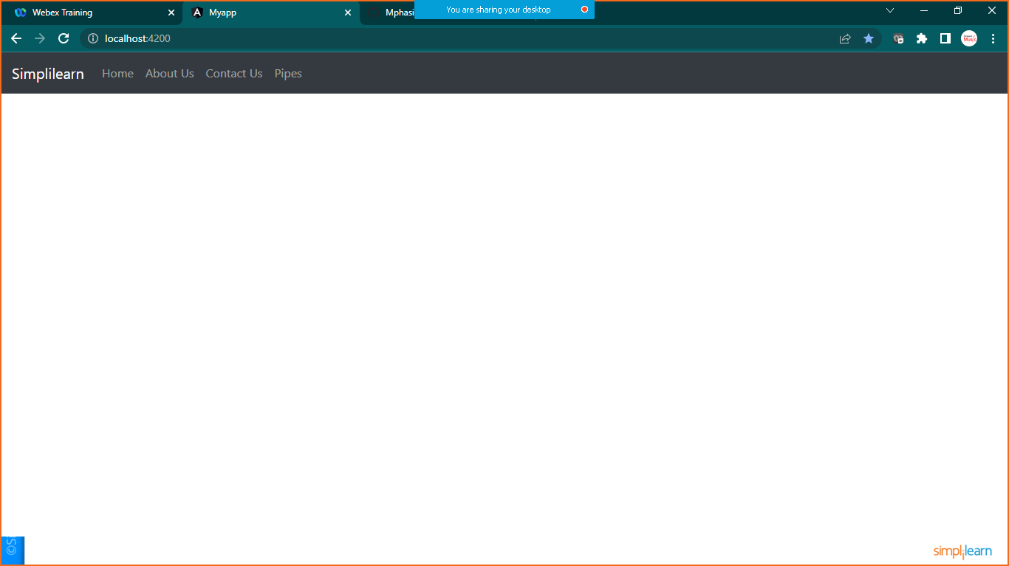

Home page

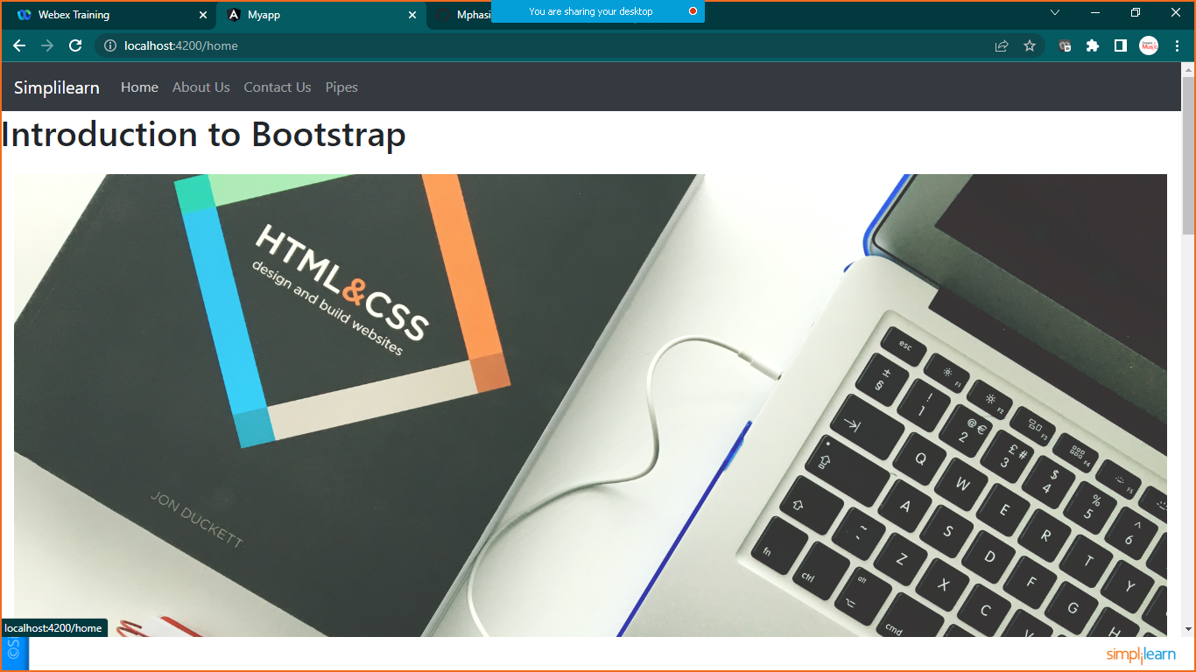

About us page

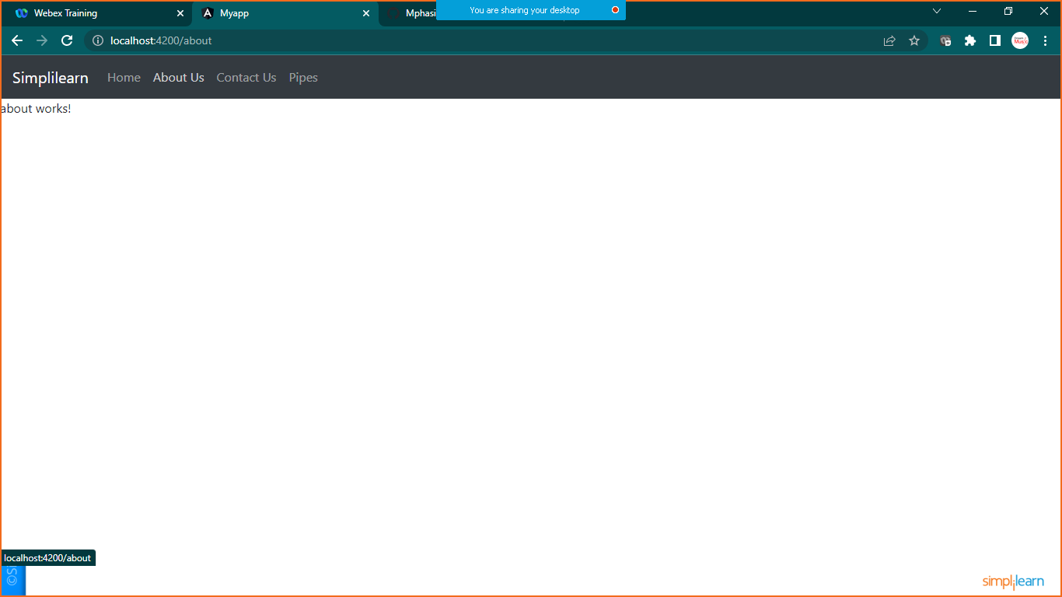

Contact us page

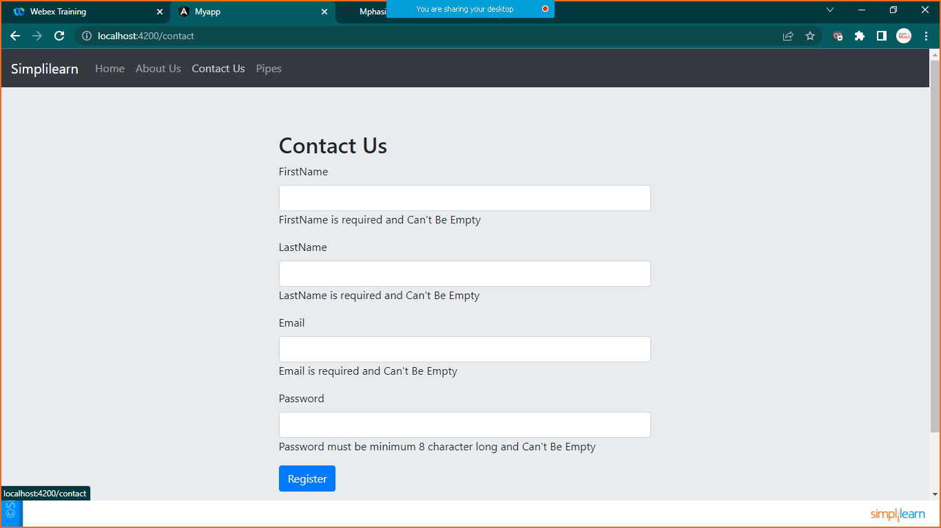

Pipes page

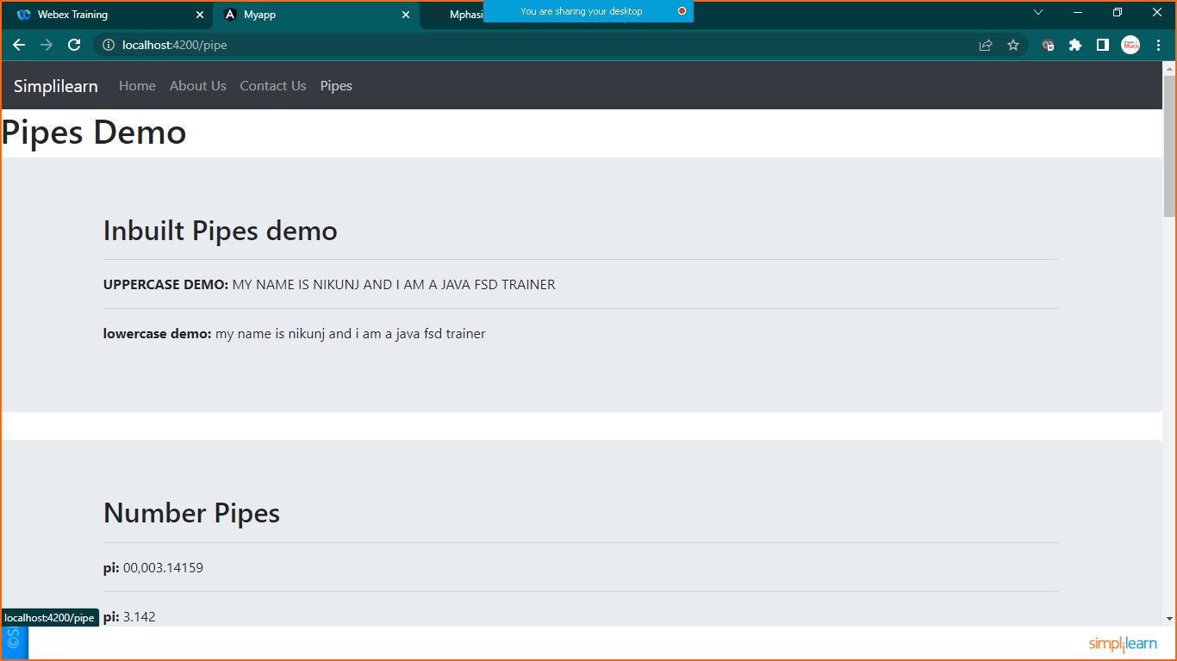

Note: you can add html code as per your choice

Here for reference I have merged few examples togather